**Task 6 & 7: Configuring Upstream , Downstream Jobs & Cron Job**

1. Created 3 Jobs:

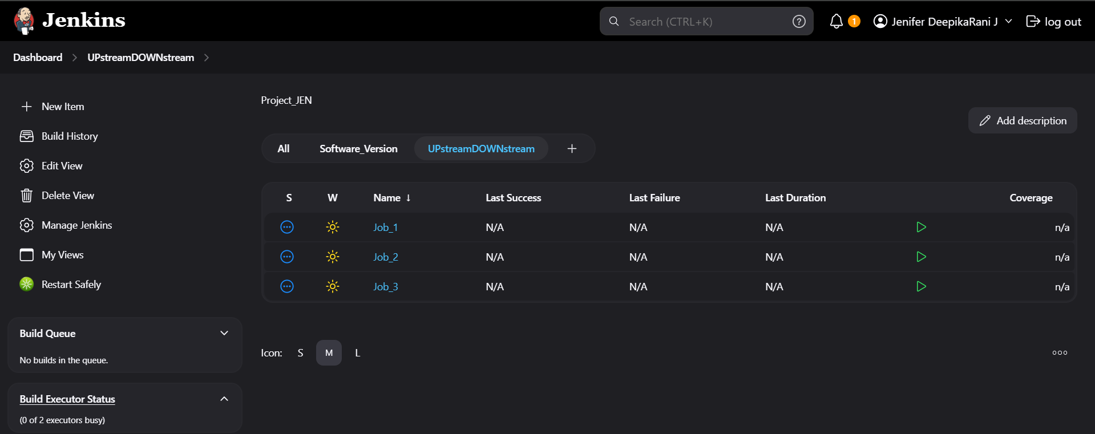

1. Using Post build actions I have configure the downstream job for Job_1

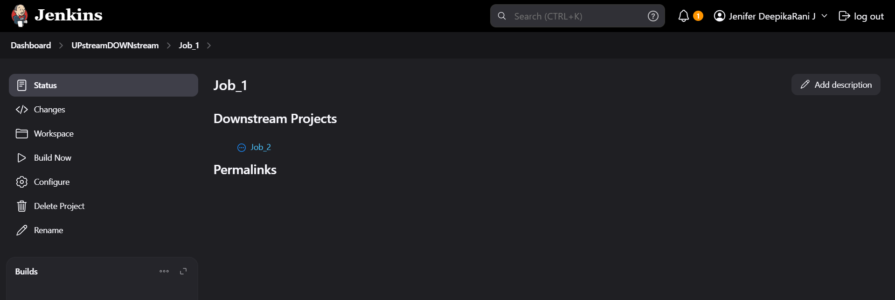

1. Configuring the Post build actions for Job_2

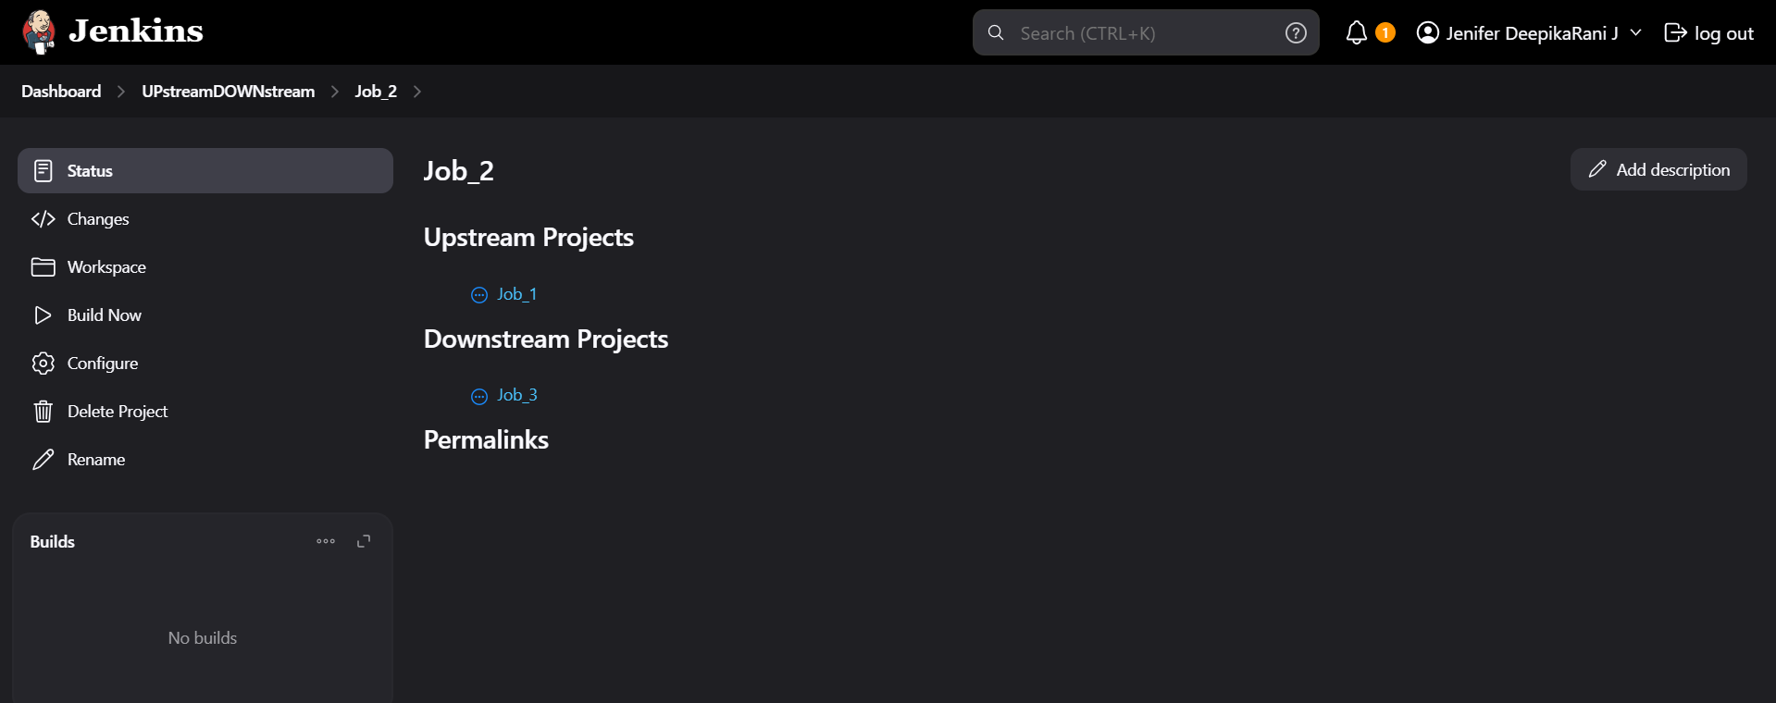

1. Configuring the Post build actions for Job_3

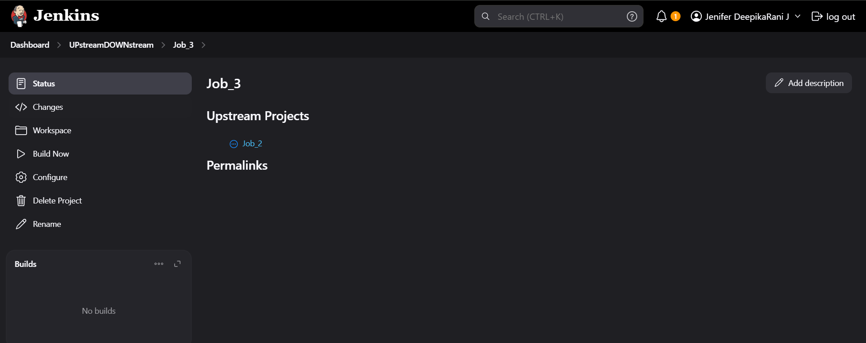

1. Timer configuring for Cron Job to Job_1

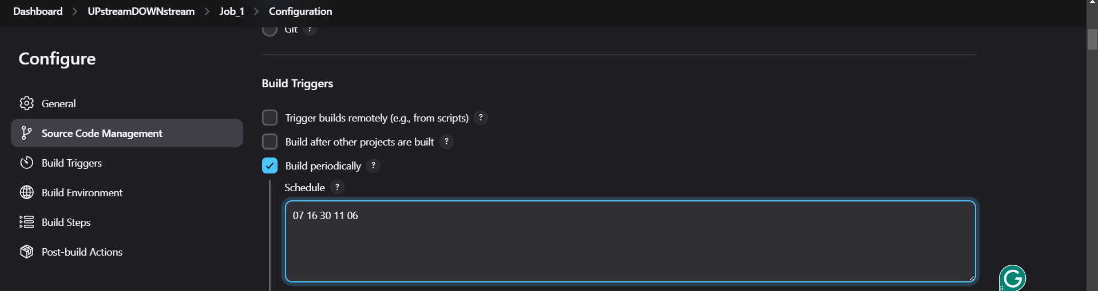

**The Outputs:**

1. Job-1 has triggered using Timer

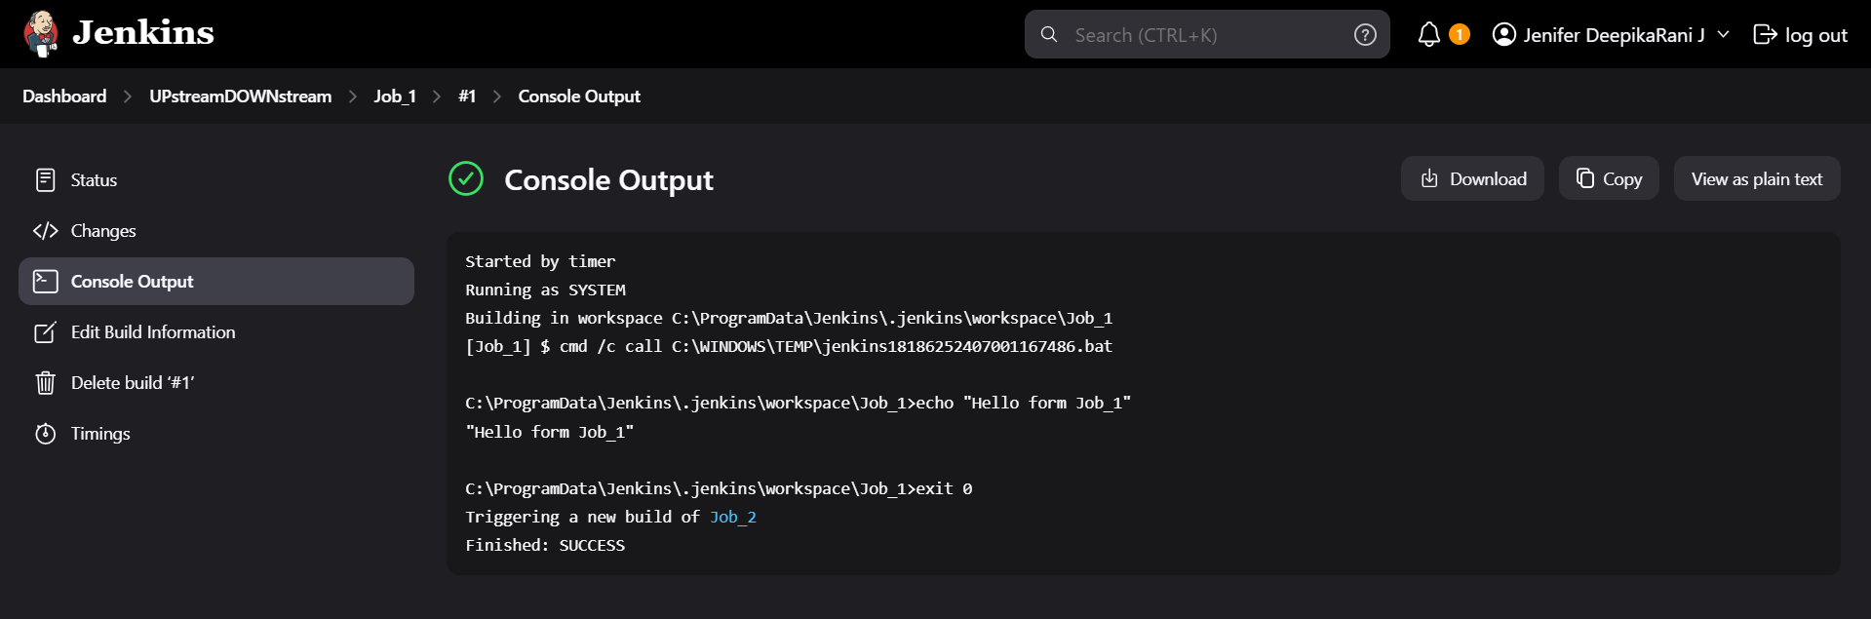

1. Job_2 triggered by Job_1 via configuring upstream & downstream jobs

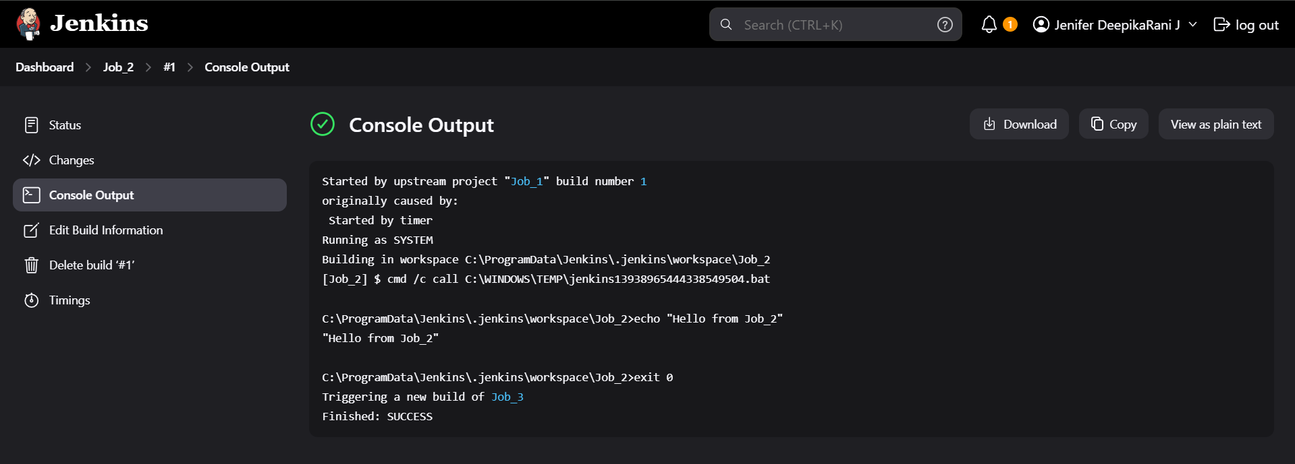

1. Job_3 triggered by Job_2 via configuring upstream & downstream jobs

